**Swetha Shree Byllahali Ananthaswamy**

**Information Technology Management**

**IFT-598 Middleware Prog & Database Sec**

**Professor: Dinesh Sthapit**

**Due Date: 09/24/2022**

**Module 3 Assignment: Data Format**

export const generateRandomNumber = function (minimum, maximum){

    return Math.floor(Math.random() * (maximum - minimum)) + minimum

}

console.log(`From Utility File ${generateRandomNumber(10,100)}`);

import * as Game from './utility.js'

console.log(`From index File ${Game.generateRandomNumber(10,100)}`);

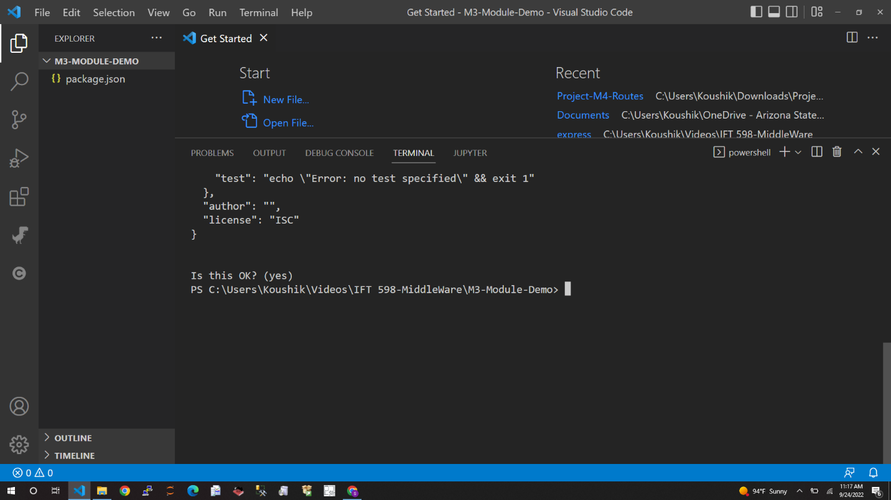

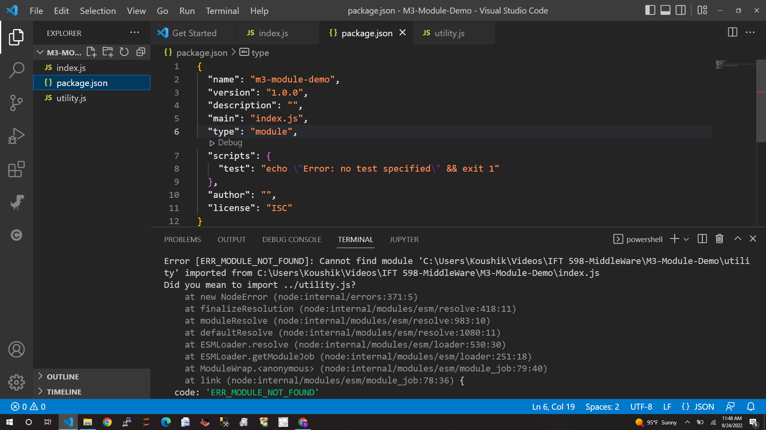

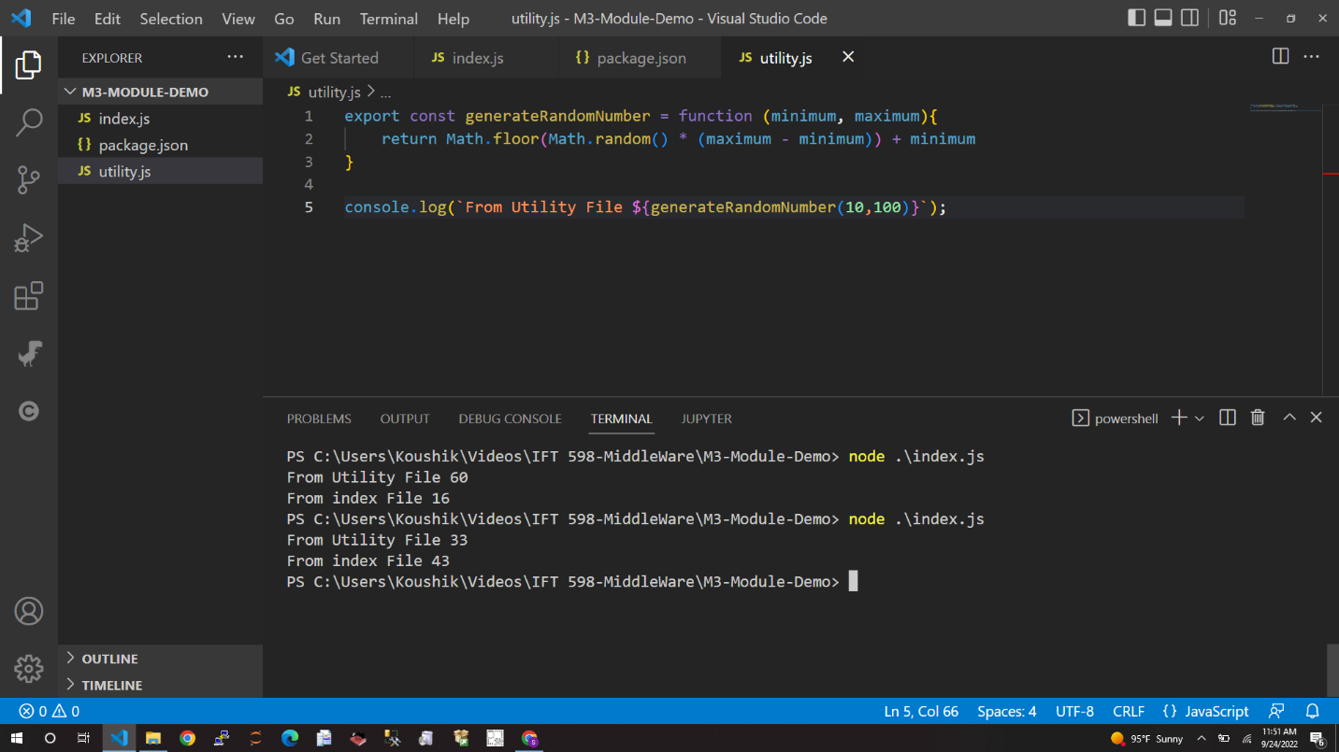

const cars = [{"Make_ID":440,"Make_Name":"ASTON MARTIN","Model_ID":1684,"Model_Name":"V8 Vantage"},{"Make_ID":440,"Make_Name":"ASTON MARTIN","Model_ID":1686,"Model_Name":"DBS"},{"Make_ID":440,"Make_Name":"ASTON MARTIN","Model_ID":1687,"Model_Name":"DB9"},{"Make_ID":440,"Make_Name":"ASTON MARTIN","Model_ID":1688,"Model_Name":"Rapide"},{"Make_ID":440,"Make_Name":"ASTON MARTIN","Model_ID":1695,"Model_Name":"V12 Vantage"},{"Make_ID":440,"Make_Name":"ASTON MARTIN","Model_ID":1697,"Model_Name":"Virage"},{"Make_ID":440,"Make_Name":"ASTON MARTIN","Model_ID":1701,"Model_Name":"Vanquish"},{"Make_ID":440,"Make_Name":"ASTON MARTIN","Model_ID":13751,"Model_Name":"DB11"},{"Make_ID":440,"Make_Name":"ASTON MARTIN","Model_ID":14157,"Model_Name":"Lagonda"},{"Make_ID":440,"Make_Name":"ASTON MARTIN","Model_ID":14162,"Model_Name":"Vantage"},{"Make_ID":440,"Make_Name":"ASTON MARTIN","Model_ID":14164,"Model_Name":"V8"},{"Make_ID":440,"Make_Name":"ASTON MARTIN","Model_ID":19609,"Model_Name":"Vanquish S"},{"Make_ID":440,"Make_Name":"ASTON MARTIN","Model_ID":19610,"Model_Name":"Vanquish Zagato"},{"Make_ID":440,"Make_Name":"ASTON MARTIN","Model_ID":27591,"Model_Name":"DBX"}]

console.log(cars[3]);

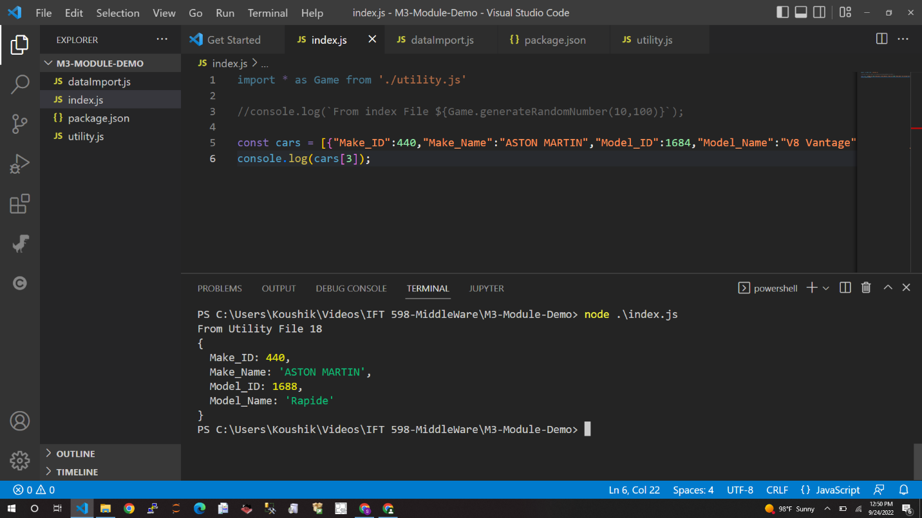

import fetch from 'node-fetch'

const apiURL ='https://swapi.dev/api/people/2'

fetch(apiURL)

.then(res => res.json())

.then(json=>{

    console.log(json)

    console.log(` all  data was received successfully `);

})

console.log(`Getting data`);//ansync programming.

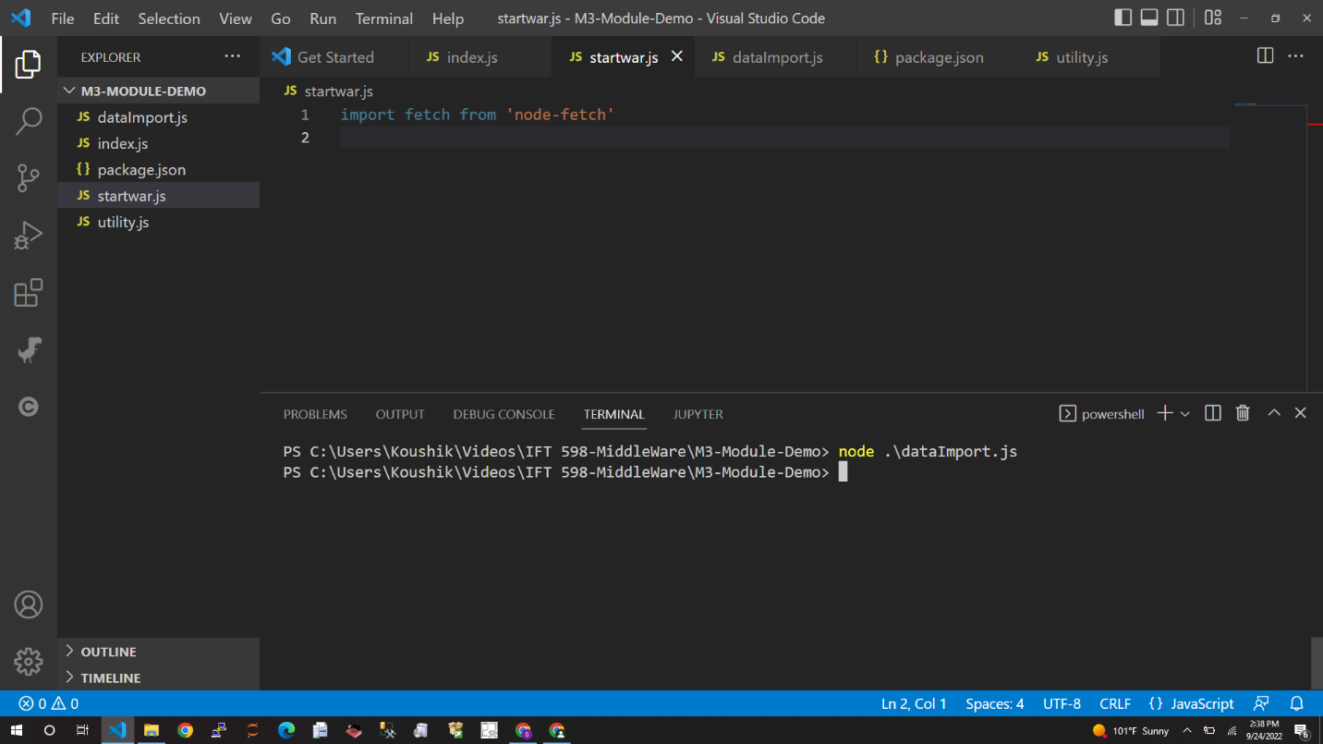

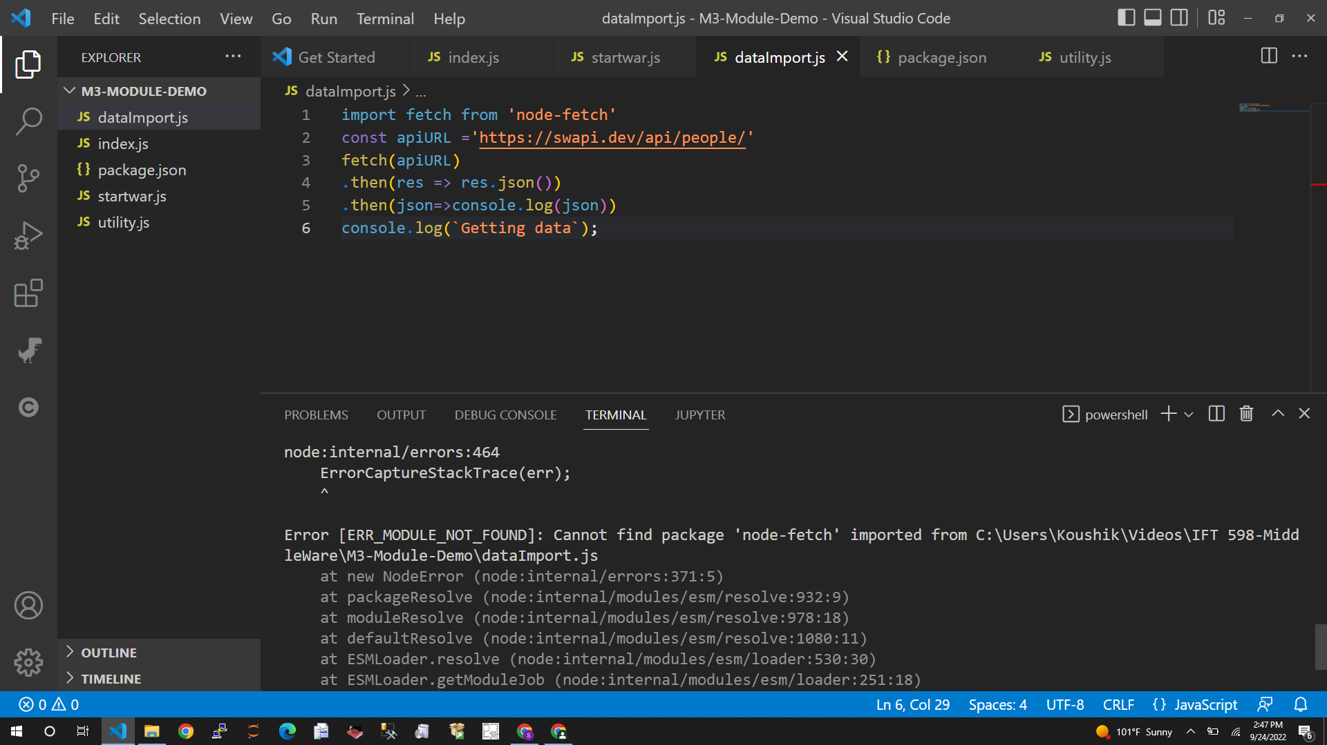

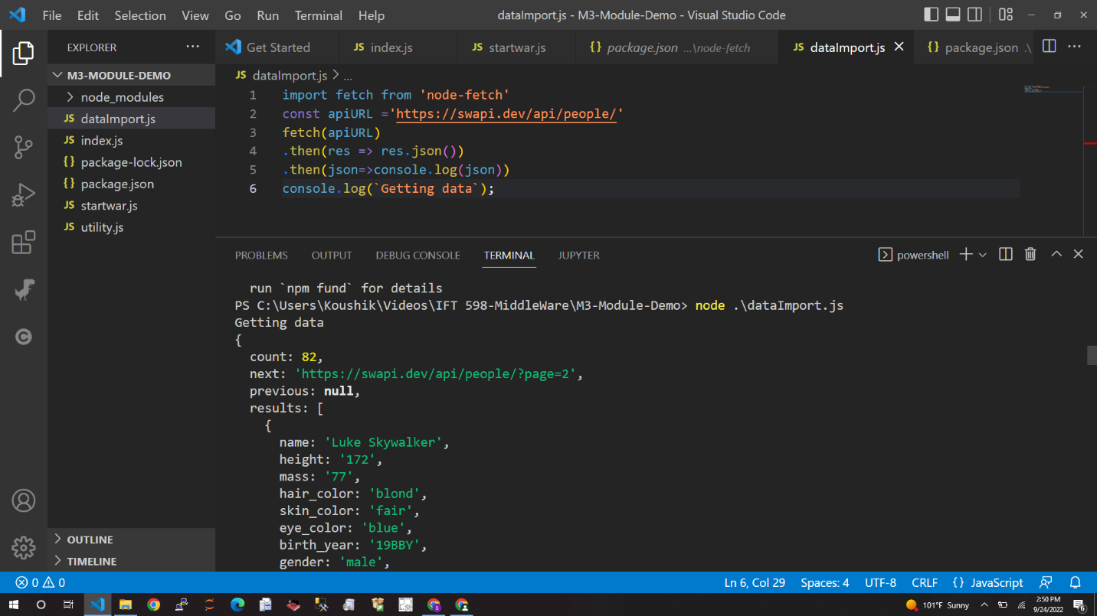

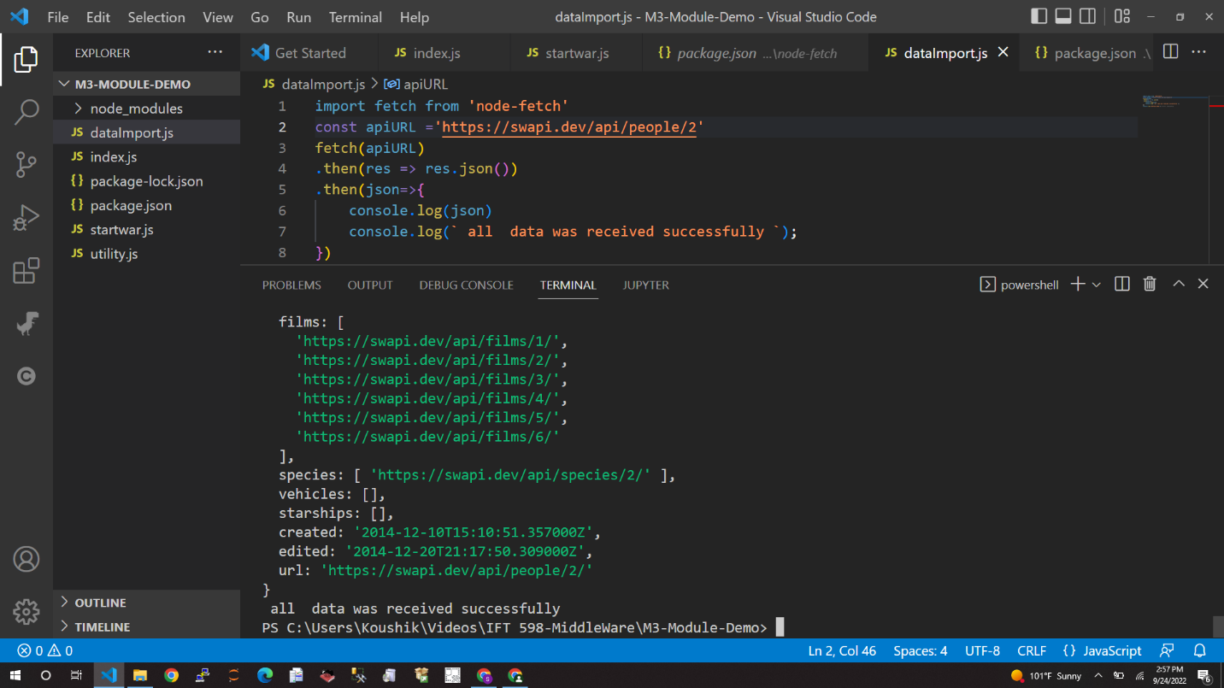

import fetch from 'node-fetch'

var query ='https://swapi.dev/api/people/1'

fetch(query ,{

    method: 'GET',

    headers: {

        'Content-Type': 'application/xml',

        'accept': 'application/json',

        'User-Agent':'*'

    },

}).then(function(response){

    console.log(`response = ${response}`);

    return response.text()

}).then(function(xml){

    console.log(`XML = ${xml}`);

}).catch((error) =>{

    console.log(`ERROR:`, error);

});



